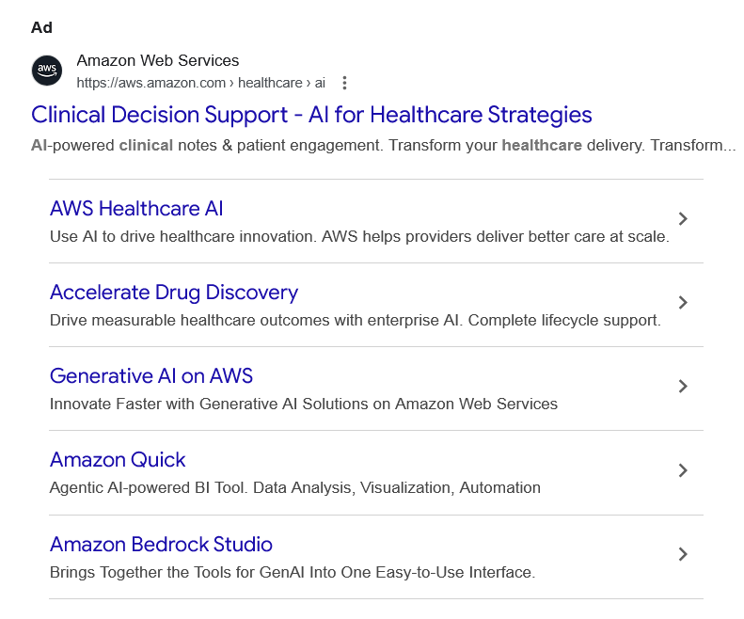
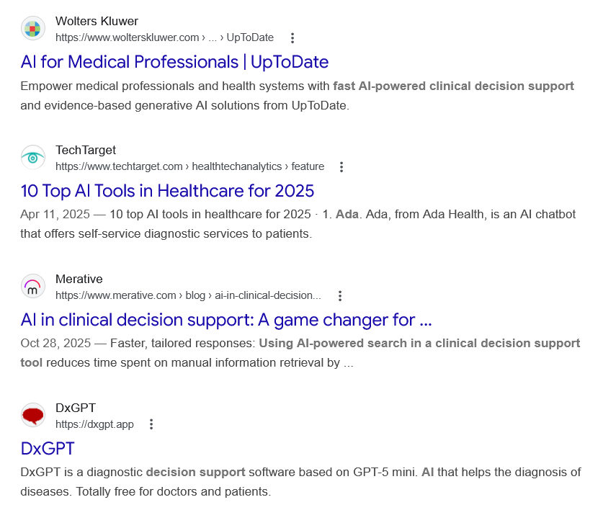
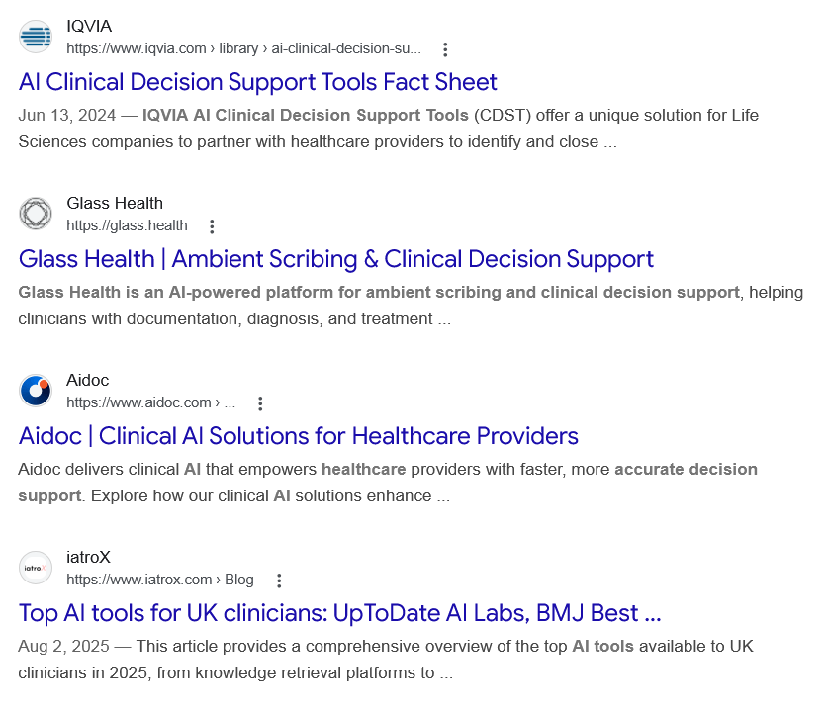
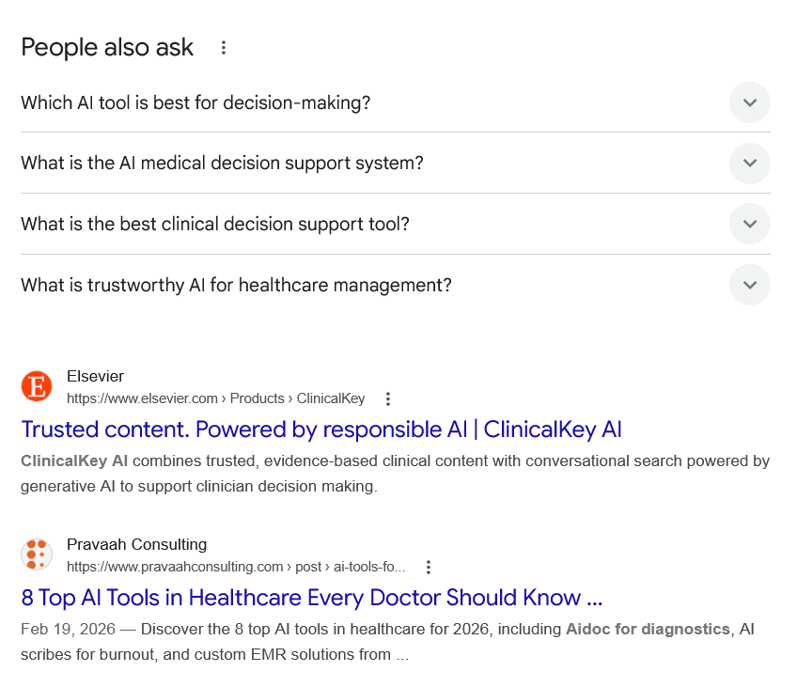
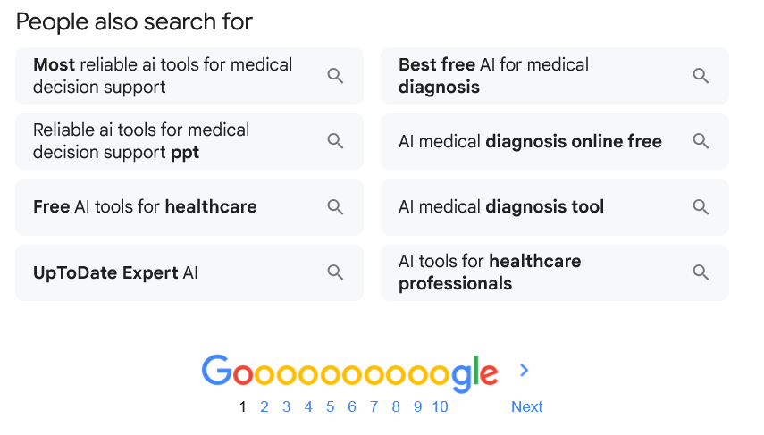
Ad

Clinical Decision Support - AI for Healthcare Strategies
Amazon Web Services
https://aws.amazon.com › healthcare › ai

Amazon Web Services
https://aws.amazon.com › healthcare › ai

My Ad Centre
AI-powered clinical notes & patient engagement. Transform your healthcare delivery. Transform...

AWS Healthcare AI
Use AI to drive healthcare innovation. AWS helps providers deliver better care at scale.

Accelerate Drug Discovery
Drive measurable healthcare outcomes with enterprise AI. Complete lifecycle support.

Generative AI on AWS
Innovate Faster with Generative AI Solutions on Amazon Web Services

Amazon Quick
Agentic AI-powered BI Tool. Data Analysis, Visualization, Automation

Amazon Bedrock Studio
Brings Together the Tools for GenAI Into One Easy-to-Use Interface.

People also search for

Web results

AI for Medical Professionals | UpToDate

Wolters Kluwer
https://www.wolterskluwer.com › ... › UpToDate

Wolters Kluwer
https://www.wolterskluwer.com › ... › UpToDate
Empower medical professionals and health systems with fast AI-powered clinical decision support and evidence-based generative AI solutions from UpToDate.

10 Top AI Tools in Healthcare for 2025

TechTarget
https://www.techtarget.com › healthtechanalytics › feature

TechTarget
https://www.techtarget.com › healthtechanalytics › feature
Apr 11, 2025 — 10 top AI tools in healthcare for 2025 · 1. Ada. Ada, from Ada Health, is an AI chatbot that offers self-service diagnostic services to patients.

AI in clinical decision support: A game changer for ...

Merative
https://www.merative.com › blog › ai-in-clinical-decision...

Merative
https://www.merative.com › blog › ai-in-clinical-decision...
Oct 28, 2025 — Faster, tailored responses: Using AI-powered search in a clinical decision support tool reduces time spent on manual information retrieval by ...

DxGPT

DxGPT
https://dxgpt.app

DxGPT
https://dxgpt.app
DxGPT is a diagnostic decision support software based on GPT-5 mini. AI that helps the diagnosis of diseases. Totally free for doctors and patients.

AI Clinical Decision Support Tools Fact Sheet

IQVIA
https://www.iqvia.com › library › ai-clinical-decision-su...

IQVIA
https://www.iqvia.com › library › ai-clinical-decision-su...
Jun 13, 2024 — IQVIA AI Clinical Decision Support Tools (CDST) offer a unique solution for Life Sciences companies to partner with healthcare providers to identify and close ...

Glass Health | Ambient Scribing & Clinical Decision Support

Glass Health
https://glass.health

Glass Health
https://glass.health
Glass Health is an AI-powered platform for ambient scribing and clinical decision support, helping clinicians with documentation, diagnosis, and treatment ...

Aidoc | Clinical AI Solutions for Healthcare Providers

Aidoc
https://www.aidoc.com › ...

Aidoc
https://www.aidoc.com › ...
Aidoc delivers clinical AI that empowers healthcare providers with faster, more accurate decision support. Explore how our clinical AI solutions enhance ...

Top AI tools for UK clinicians: UpToDate AI Labs, BMJ Best ...

iatroX
https://www.iatrox.com › Blog

iatroX
https://www.iatrox.com › Blog
Aug 2, 2025 — This article provides a comprehensive overview of the top AI tools available to UK clinicians in 2025, from knowledge retrieval platforms to ...
People also ask
Which AI tool is best for decision-making?
Best AI Decision-Making Software Summary
 | Tool | Best For
1 | Deel HR | Best for compliance decisions
2 | Anaplan | Best for business planning
3 | Tableau | Best for data visualization
4 | Google DeepMind | Best for AI research
6 more rows
•
Feb 17, 2026

15 Best AI Decision-Making Software Reviewed in 2026

People Managing People
https://peoplemanagingpeople.com › tools › best-ai-decis...

People Managing People
https://peoplemanagingpeople.com › tools › best-ai-decis...
What is the AI medical decision support system?

AI-driven clinical decision support systems (CDSS) further assist physicians in improving drug compliance and optimizing population health strategies by identifying pharmacologically cost-effective therapies.

AI-driven clinical decision support systems - ScienceDirect.com

ScienceDirect.com
https://www.sciencedirect.com › article › abs › pii

ScienceDirect.com
https://www.sciencedirect.com › article › abs › pii
What is the best clinical decision support tool?
Ranked one of the best clinical decision support tools for health professionals worldwide*, BMJ Best Practice provides step-by-step guidance on diagnosis, treatment and prevention.

BMJ Best Practice: Homepage

The BMJ
https://bestpractice.bmj.com

The BMJ
https://bestpractice.bmj.com
What is trustworthy AI for healthcare management?

What is Trustworthy AI. Trustworthy AI (TAI) is a framework to mitigate the various forms of risk arising from AI. Created by the US Department of Health and Human Services in 2021, the framework offers detailed guidance to ensure that health-related AI is implemented in a way that is ethical, effective and secure.

Trustworthy AI | AI@UCSF

Artificial Intelligence at UCSF - University of California San Francisco
https://ai.ucsf.edu › trustworthy

Artificial Intelligence at UCSF - University of California San Francisco
https://ai.ucsf.edu › trustworthy

Web results

Trusted content. Powered by responsible AI | ClinicalKey AI

Elsevier
https://www.elsevier.com › Products › ClinicalKey

Elsevier
https://www.elsevier.com › Products › ClinicalKey
ClinicalKey AI combines trusted, evidence-based clinical content with conversational search powered by generative AI to support clinician decision making.

8 Top AI Tools in Healthcare Every Doctor Should Know ...

Pravaah Consulting
https://www.pravaahconsulting.com › post › ai-tools-fo...

Pravaah Consulting
https://www.pravaahconsulting.com › post › ai-tools-fo...
Feb 19, 2026 — Discover the 8 top AI tools in healthcare for 2026, including Aidoc for diagnostics, AI scribes for burnout, and custom EMR solutions from ...
People also search for

Most reliable ai tools for medical decision support

Reliable ai tools for medical decision support ppt

Free AI tools for healthcare

UpToDate Expert AI

Best free AI for medical diagnosis

AI medical diagnosis online free

AI medical diagnosis tool

AI tools for healthcare professionals

Page navigation
 | 1 | 2 | 3 | 4 | 5 | 6 | 7 | 8 | 9 | 10 | Next

